**Lab 8**

**The Tiny Sorter**

**Worth 20%**

**Due date: Sun 17th March**

**Purpose**

You will create an automatic object detection and classification system using the pretrained convolutional neural network “mobilenet” model via a process of transfer learning (but this is all done for you by the Teachable Machines website).

There are a few parts to this exercise which will give you exposure to the reality of putting a functioning physical system together. These include:

* building the physical sorter machine
* implementing the electric circuit for the servo arm
* programming the microcontroller
* running a web server
* connecting the microcontroller to the web browser
* training a convolutional neural network with multiple classes

**Setup**

You will need

* A laptop with a webcam
* Two small/tiny objects of your choice.

You will be provided with

* An Arduino kit
* The sorter design template
* Scissors and tape
* All the necessary source code files

**To Do**

You are to complete the online tutorial:

<https://experiments.withgoogle.com/tiny-sorter/view>

Make sure you read my **Readme.docx** file for specifics. It includes the learnings I made when I did the project. It will be invaluable! Use the source code I have provided on Blackboard, not the versions from the tutorial. I had to make a couple of enhancements in sketch.js and serial.js.

You are to **pick your own 2 items for sorting**. I used a USB cap and a ball of tin foil !

You are to create a video demonstrating your completed sorter in action. The video should adequately show me all the necessary points listed below.

You should have your name on the sorter clearly visible in the video:

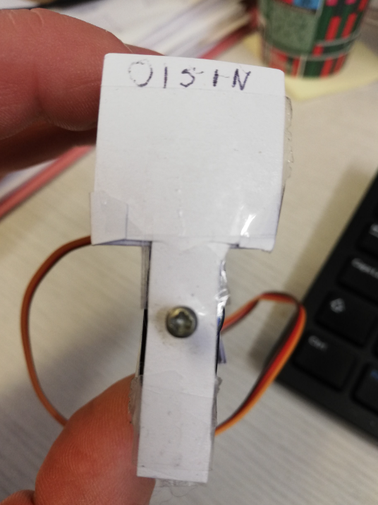

I got the tutorial to work successfully on Windows using both Chrome and Edge browsers.

Check out:

<https://www.veed.io/view/810de6df-325d-4581-847a-3ecd4d47d6d9?panel=share>

or see the demo video on Blackboard.

**Marking:**

It is possible to score 100% here if the system works perfectly.

1. Website up and running on a local web server (10)
2. Arduino
   1. Code loaded and running (10)
   2. Servo connected and moving as intended (10)
3. Web browser connected to Arduino (10)
4. Your model trained on your own 2 objects and empty category (10)
5. Model loading to website and running successfully (10)
6. Objects feeding into sorter (10)
7. Website correctly controlling the Arduino depending on the object detected (30)